1. Six sigma definitions:

* In statistics and probability theory, the standard deviation (represented by the Greek letter sigma, σ) shows how much variation or dispersion from the average exists. A low standard deviation indicates that the data points tend to be very close to the mean (also called expected value); a high standard deviation indicates that the data points are spread out over a large range of values.
* Six Sigma is a management philosophy developed by Motorola that emphasizes setting extremely high objectives, collecting data, and analyzing results to a fine degree as a way to reduce defects in products and services. The central idea behind Six Sigma is that if you can measure how many “defects” you have in a process, you can systematically figure out how to eliminate them and get as close to “zero defects” as possible.
* We think about Six Sigma at three different levels:
* As a metric
* As a methodology
* As a management system
* Essentially, Six Sigma is lots of different things because it had different meanings over time, and also because it is now interpreted in increasingly different ways. At many organizations it simply means a measure of quality that strives for near perfection, so Six Sigma is still evolving.
* To achieve Six Sigma quality, a process must produce no more than 3.4 defects per million opportunities. An “opportunity” is defined as a chance for nonconformance, or not meeting the required specifications. This means we need to be nearly flawless in executing our key processes. Six Sigma is a vision we strive toward and a philosophy that is part of our business culture. Six Sigma revolves around a few key concepts:
* Critical to Quality: Attributes most important to the customer
* Defect: Failing to deliver what the customer wants
* Process Capability: What your process can deliver
* Variation: What the customer sees and feels
* Stable Operations: Ensuring consistent, predictable processes to improve what the customer sees and feels
* Design for Six Sigma: Designing to meet customer needs and process capability.

1. History:

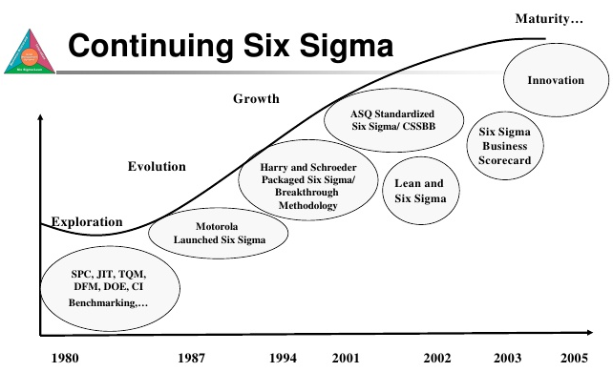

* The roots of Six Sigma as a measurement standard can be traced back to Carl Frederick Gauss (1777-1855) who introduced the concept of the normal curve. Six Sigma as a measurement standard in product variation can be traced back to the 1920′s when Walter Shewhart showed that three sigma from the mean is the point where a process requires correction. Many measurement standards (Cpk, Zero Defects, etc.) later came on the scene but credit for coining the term “Six Sigma” goes to a Motorola engineer named Bill Smith. (Incidentally, “Six Sigma” is a federally registered trademark of Motorola).
* In the early and mid-1980s with Chairman Bob Galvin at the helm, Motorola engineers decided that the traditional quality levels — measuring defects in thousands of opportunities – didn’t provide enough granularity. Instead, they wanted to measure the defects per million opportunities. Motorola developed this new standard and created the methodology and needed cultural change associated with it. Six Sigma helped Motorola realize powerful bottom-line results in their organization – in fact, they documented more than $16 Billion in savings as a result of our Six Sigma efforts.
* Since then, hundreds of companies around the world have adopted Six Sigma as a way of doing business. This is a direct result of many of America’s leaders openly praising the benefits of Six Sigma. Leaders such as Larry Bossidy of Allied Signal (now Honeywell), and Jack Welch of General Electric Company. Rumor has it that Larry and Jack were playing golf one day and Jack bet Larry that he could implement Six Sigma faster and with greater results at GE than Larry did at Allied Signal. The results speak for themselves.
* Six Sigma has evolved over time. It’s more than just a quality system like TQM or ISO. It’s a way of doing business. As Geoff Tennant describes in his book Six Sigma: SPC and TQM in Manufacturing and Services: “Six Sigma is many things, and it would perhaps be easier to list all the things that Six Sigma quality is not. Six Sigma can be seen as: a vision; a philosophy; a symbol; a metric; a goal; a methodology.”

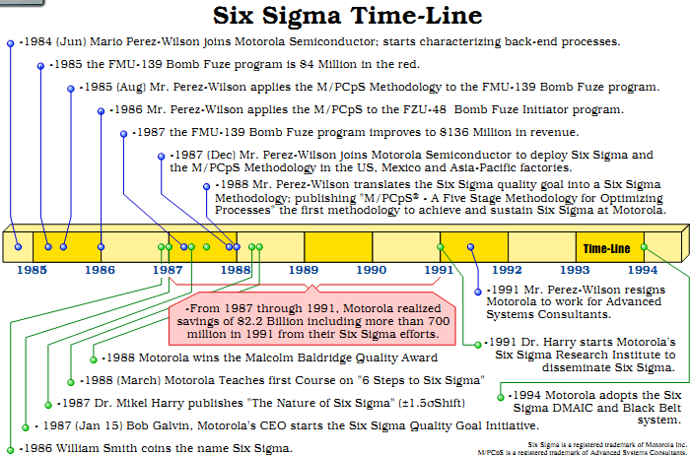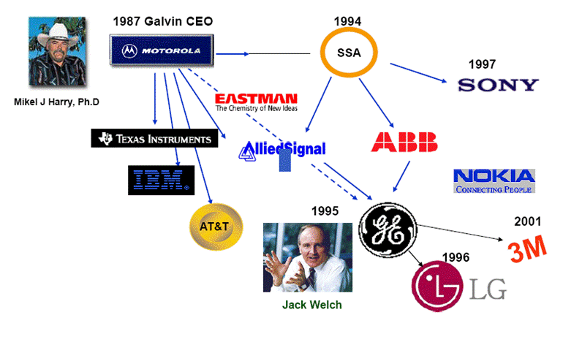

1. Why Six Sigma is Important

* There are three key elements of quality: customer, process and employee. Everything we do to remain quality focuses on these three essential elements:
* Delighting Customers: Customers are the center of universe: they define quality. They expect performance, reliability, competitive prices, on-time delivery, service, clear and correct transaction processing and more. In every attribute that influences customer perception, we know that just being good is not enough. Delighting customers is a necessity. Because if we don’t do it, someone else will!
* Processes Outside-In Thinking: Quality requires us to look at our business from the customer’s perspective, not ours. In other words, we must look at our processes from the outside-in. By understanding the transaction lifecycle from the customer’s needs and processes, we can discover what they are seeing and feeling. With this knowledge, we can identify areas where we can add significant value or improvement from their perspective.
* Leadership Commitment: People create results. Involving all employees is essential to project quality approach. Project must be committed to providing opportunities and incentives for employees to focus their talents and energies on satisfying customers.
* All employees are trained in the strategy, statistical tools and techniques of Six Sigma quality.
* Six Sigma is valuable because it creates an environment for improving productivity and efficiency in a business environment of continuous improvement. It gives everyone an opportunity to make improvements to traditional processes. It creates a disciplined, knowledge-based approach designed to enhance customer satisfaction and build a customer culture that embraces innovative approaches to technology and business development. Overall, it is a highly structured strategy for acquiring, assessing and applying customer expectations with manageable solutions for the purposes of product, system or enterprise innovation and design.
* Most companies operate at three or Four Sigma. That means the losses they incur as a result of poor quality cost them 10 to 15 percent of their revenue. A company operating at Six Sigma. However, can generate considerable savings. According to one source, the savings as a percentage of revenue vary from 1.2 percent to 4.5 percent [source: I Six Sigma]. That means a company with revenues of $1 million could save up to $45,000, and a company with revenues of $1 billion could save up to $45,000,000.

1. Role and Responsibility:

* One key innovation of Six Sigma involves the absolute "professionalizing" of quality management functions. Prior to Six Sigma, quality management in practice was largely relegated to the production floor and to [statisticians](http://en.wikipedia.org/wiki/Statistician) in a separate quality department. Formal Six Sigma programs adopt a kind of elite ranking terminology (similar to some martial arts systems, like Kung-Fu and Judo) to define a hierarchy (and special career path) that kicks across all business functions and levels.
* Six Sigma identifies several key roles for its successful implementation.

|  |  |  |
| --- | --- | --- |
| **Roles** | **Definition & Responsibilities** | **What do they do?** |
| Executives | **I**ncludes the CEO and other members of top management. They are responsible for setting up a vision for Six Sigma implementation. They also empower the other role holders with the freedom and resources to explore new ideas for breakthrough improvements. | * The executives legitimize the changes about to happen * Establish the vision—why we are doing Six Sigma. * Articulate the business strategy—how Six Sigma supports the business strategy. * Provide resources. * Remove roadblocks and buffer conflicts. * Support the culture change by encouraging others to take the risk and make the change. * Monitor the results by defining the scorecard for Six Sigma and holding others accountable for the results. * Align the systems and structures with the changes taking place. * Participate with the black belts through project reviews and recognition of results. |
| Champions | Champions take responsibility for Six Sigma implementation across the organization in an integrated manner. The Executive Leadership draws them from upper management. Champions also act as mentors to Black Belts. | * An officially designated person who has primary responsibility for helping management plan and manage the change process * Develop a vision for the organization. * Create and maintain passion. * Develop a model for a perfect organization. * Facilitate the identification and prioritization of projects. * Develop the strategic decisions in the deployment of Six Sigma around timing and sequencing of manufacturing, transactional, and new product focus. * Extend project benefits to additional areas. * Communicate and market the breakthrough strategy process and results. * Share best practices. * Establish and monitor a team process for optimum results. * Recruit, inspire and "free up" black belts—pick the best people. * Develop the reward and recognition program for black belts. * Remove barriers for black belts. * Coach and develop black belts. * Provide the drum beat for results by reviewing projects and keeping score through metrics. * Develop a comprehensive training plan for implementing the breakthrough strategy. |
| Master black belt | Identified by champions, act as in-house coaches on Six Sigma. They devote 100% of their time to Six Sigma. They assist champions and guide Black Belts and Green Belts. Apart from statistical tasks, they spend their time on ensuring consistent application of Six Sigma across various functions and departments. | * Be the expert in the tools and concepts. * Develop and deliver training to various levels of the organization. * Certify the black belts with additional specialized skills or experience especially useful in deployment of Six Sigma across the enterprise * Assist in the identification of projects. * Coach and support the black belts in project work. * Participate in project reviews to offer technical expertise. * Collaborate with the champions. * Demonstrate passion around Six Sigma. * Share best practices. * Take on leadership of major programs. * Develop new tools or modify old tools for application. * Understand the link between Six Sigma and the business strategy. * Permanent full-time change agent |
| Black belt | Operate under Master Black Belts to apply Six Sigma methodology to specific projects. They devote 100% of their valued time to Six Sigma. They primarily focus on Six Sigma project execution and special leadership with special tasks, whereas Champions and Master Black Belts focus on identifying projects/functions for Six Sigma. | * Expert in leading project execution with relevant experience in one or more specific fields; extensive training and strong background in statistics and analysis. * Understand how to implement the breakthrough strategy application. * Prepare initial project assessment to validate benefits. * Lead and direct the team to execute projects. * Determine the most effective tools to apply. * Show the data. * Identify barriers. * Identify project resources. * Determine appropriate and applicable input from knowledgeable functional experts/team leaders/coaches. * Report progress to appropriate leadership levels. * Present the final report. * Deliver results on time. * Solicit help from the champions when needed. * Influence without direct authority. * Be a breakthrough strategy enthusiast. * Stimulate champion thinking. * Teach and coach breakthrough strategy methods and tools. * Manage project risk. * Ensure the results are sustained. * Document Learning. |
| Green Belt | Are the employees who take up Six Sigma implementation along with their other job responsibilities, operating under the guidance of Black Belts. | * who current positions are associated with the problem to be solved while performing their regular duties, familiar with basic statistical tools and less intensive in training * Six Sigma project originator * Six Sigma project leader * Part-time Six Sigma * Change agent. Continues to perform normal duties while participating on Six Sigma project teams * Six Sigma champion in local area |
| Yellow Belt (Team members) |  | * Provide the everyday requirements for execution of the DMAIC model. They also help spread the word about six sigma tools and processes and ultimately they become part of the reservoir of human resources available for future projects |
| White Belt (Process owner) |  | * This person takes on a new, cross-functional responsibility to manage all the steps that provide value to the internal as well as external customer. The sponsor and the process owner may be the same person. |

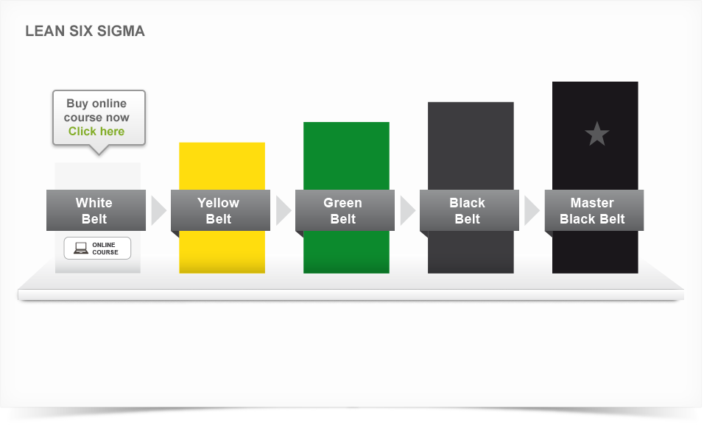

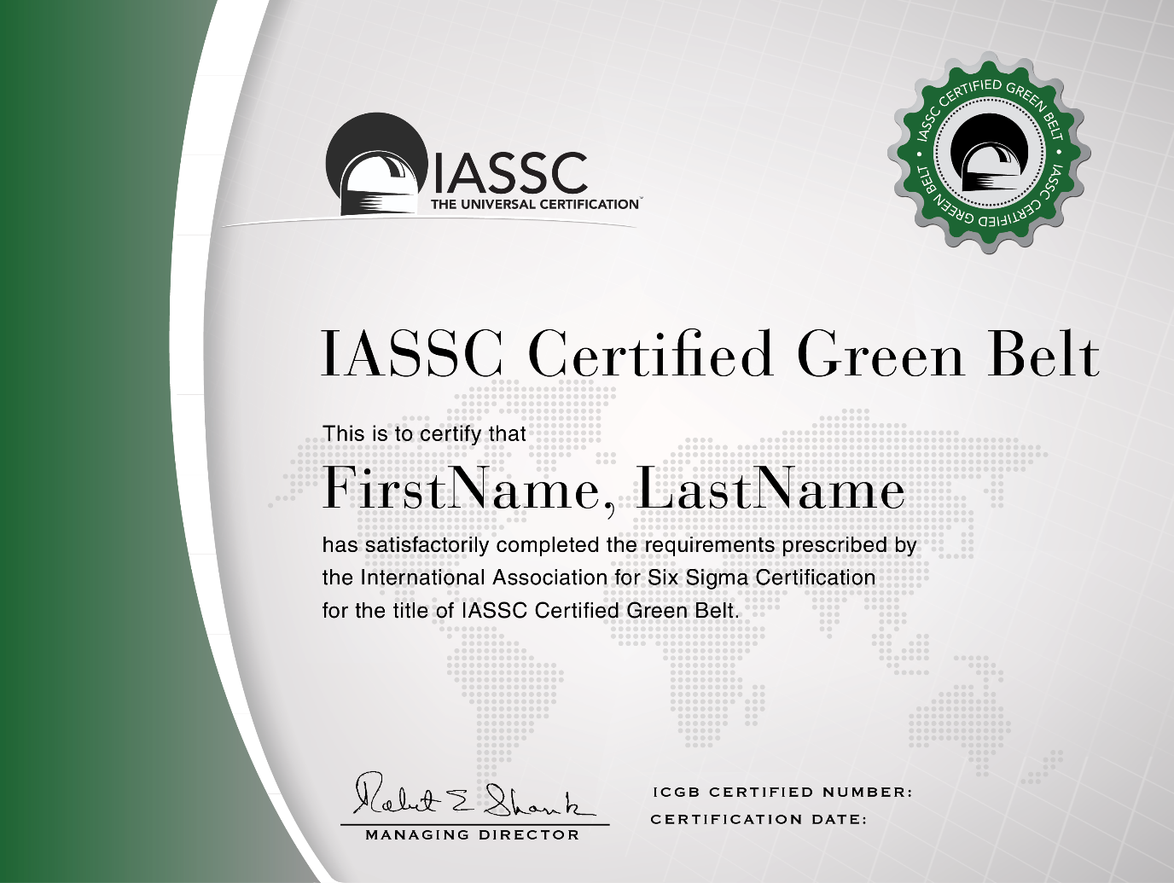

1. Area application

* Six Sigma is an “Industry Independent” methodology and has been successfully applied across:
* Manufacturing Industry including Auto motives, Aerospace, Health Equipment, FMCG, Electronic Goods, Continuous process Industries, Textiles, etc.
* Service Industry including Telecom, banking and Financial Services, Health Care, hotels, IT, ITES, KOPs, Airline, Cargo movement, Support Service, HR services, Marketing Service, etc.
* R&D organizations or in R&D function of various organizations for example

Table 1 . Area application of Six Sigma

|  |  |
| --- | --- |
| **Industry** | **Examples of Six Sigma Applicability** |
| Automotive | * Enhancing Supplier Quality * Improving Safety & Reliability of Finished Vehicles * Reducing Manufacturing defects at each stage * Using Design FMEA to understand and prevent any possible design failures * Reducing variation in all the critical parameters that impact the finished product * Improving the overall Incoming Material Quality or parts Quality * Optimizing Inventory levels for all major parts * Reducing time to manufacture * Reducing Design defects * Reducing Supplier Lead time i.e. the time take by each supplier to deliver goods * Improving First time yield and efficiency of each step in the Manufacturing assembly line. |
| Continuous Process Plants | * Improving overall Yield of each shift * Reduce scrap or spilled materials * Reduce the Process failures or breakdowns * Increase Plant capacity utilization * Improve Operator Productivity * Reduce time to restart the process after failure * Create mechanisms to prevent failures at each stage * Improve overall process stability & control |
| Engineering Parts Manufacturing | * Reduce Manufacturing cycle time (time of order to delivery) * Improve Customer Service performance scores * Reduce or optimize inventory levels * Reduce scrap or cost of poor quality * Reduce warranty costs * Reduce rejections due to design errors * Improve parts design process to meet specifications 100% of times * Improve parts reliability by identifying & optimizing critical factors that ensure reliability |
| Information Technology :Software development | * Reducing the overall Software development times * Reducing the number of errors found during product usage * Improving the estimation process to reduce time and cost overruns * Improving the requirements gathering process to reduce rework * Reducing complaints resolution time * Creating systems to detect defects early in the process (to reduce high costs associated with defects identified later) * Reducing appraisal cost per defect by phase and appraisal type (by project and in total) * Reducing rework (All work done to fix an application after it has been delivered to a customer is rework. This includes corrections to features or functions that are incorrect, and also may include "missed requirements" - things the customer expected but did not receive. |
| Telecom | * Improving ARPU (Average revenue per unit) * Reducing Billing errors * Reducing timeliness of billing * Improving the Call Completion rate (i.e Network Quality) * Reducing network congestion * Development of new features, processes for new services * Improving accuracy, timeliness and completeness of new connections * Improving accuracy, timeliness and completeness of customer communication. * Reducing Customer churn * Reducing network congestion * Improving call routing procedures * Improving sales productivity |
| R&D/ Product Design | * Reducing the time to market * Reducing rework through synergy between R&D and the customer facing staff. * Improving the overall performance & quality of product from start * Minimizing product failures by ensuring robust designs * Improving quality of research process & experiments by providing mass education in Experimental design and Multivariate studies * Improving quality of design reviews (data driven reviews) * Reducing defects in final product thereby saving on warranty costs. |

1. Who uses Six Sigma?

* In the early days, Six Sigma was limited to complex manufacturing environments. But today, it has spread into every industry and into every functional area. According to a survey conducted by Quality
* Digest, the distribution of Six Sigma programs is now spread across a growing number of functional areas:
* Manufacturing
* Engineering
* Administration
* Test/Inspection
* Plant operation
* Customer service
* Research/Development
* Purchasing
* Sales/Marketing
* Shipping/Receiving
* Document control
* Pollution prevention
* Still, it’s not right for every company or every process. Many small companies simply lack the resources necessary to implement Six Sigma. And others with the financial resources sometimes don’t have enough support from upper management to get Six Sigma initiatives off the ground.

1. Six Sigma Calculations

* To give such numbers meaning, the engineers at Motorola set up a scale to evaluate the quality of a process based on these defect calculations. At the top of the scale is Six Sigma, which equates to 3.4 DPMO, or 99.9997% defect-free. In other words, if you have a process running at Six Sigma, you've almost eliminated all defects -- it's nearly perfect. Of course, most processes don't run at Six Sigma. They run at Five Sigma, Four Sigma or worse. Here's the full scale to get an appreciation of the numbers involved:

DPMO = \frac{1,000,000 \times \mbox{number of defects}}{\mbox{number of units} \times \mbox{number of opportunities per unit}}

* **Five Sigma** = 233 DPMO, or 99.98% defect-free
* **Four Sigma** = 6,210 DPMO, or 99.4% defect-free
* **Three Sigma** = 66,807 DPMO, or 93.3% defect-free
* **Two Sigma** = 308,538 DPMO, or 69.1% defect-free
* **One Sigma** = 691,462 DPMO, or 30.9% defect-free
* Indeed, as Six Sigma has evolved, it has become closely associated with other business strategy methodologies, such as Balanced Scorecard. That means different people at different times will define Six Sigma quite differently. Some will describe it as a metric, or a measurement of defects. Others will describe it as a methodology, a way to solve problems.

|  |  |  |  |  |
| --- | --- | --- | --- | --- |
| **Sigma level** | [**DPMO**](http://en.wikipedia.org/wiki/Defects_per_million_opportunities) | **Percent defective** | **Percentage yield** | |
| 1 | 691,462 | 69% | 31% | |
| 2 | 308,538 | 31% | 69% | |
| 3 | 66,807 | 6.7% | 93.3% | |
| 4 | 6,210 | 0.62% | 99.38% | |
| 5 | 233 | 0.023% | | 99.977% |
| **6** | **3.4** | **0.00034%** | | **99.99966%** |
| 7 | 0.019 | 0.0000019% | | 99.9999981% |

<http://www.businessballs.com/sixsigma.htm>

<http://www.isixsigma.com/new-to-six-sigma/history/history-six-sigma/>

<http://www.ge.com/sixsigma/keyelements.html>

<http://money.howstuffworks.com/six-sigma2.htm>

<http://money.howstuffworks.com/six-sigma1.htm>

<http://en.wikipedia.org/wiki/Six_Sigma>

<http://www.slideshare.net/BenchmarkSixSigma/six-sigma-in-various-industries>